|  |  |
| --- | --- |
|  | Fahad Alroqi |
|  | **Personal info** |
|  |  |
| First name: | Fahad |
| Last name: | Alroqi |
| Date of birth: | 09/07/1992 |
| Nationality: | Saudi Arabia |
| Address: | 4058 Dhat as Sawari, Makkah 24269, Saudi Arabia |
| Phone number: | 00966595974014 |
| Email address: | Fahad.a.Alroqi@outlook.com |

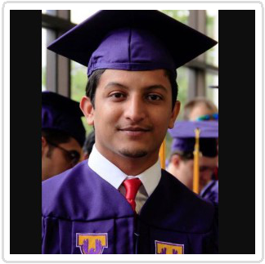

**Objective**



To obtain an entry-level position as an Engineer with ABC Technologies, allowing me to utilize my education and internship experience while gaining valuable work experience in a team oriented environment.

|  |  |  |  |  |
| --- | --- | --- | --- | --- |
|  |  | **Work experience** | |  |
|  |  | |  |  |
| **Village Volkswagen** | **intern -Training** | |  | **05/2016 – 08/2016** |
| **Chattanooga** | ● Designed | fixtures to improve parts material by AutoCAD | | |
| **United States of** | ● Created manufacturing standards that were adopted throughout CNC machine | | | |
| **America** | ● Teamed with engineering department to test design of materials | | | |
|  |  | **Education** | |  |
|  |  | | |  |
| **Tennessee** | **B.S in Manufacturing and Engineering Technology** | | | **08/2012 – 05/2017** |
| **Technological** | Manufacturing and Engineering Technology is designed to prepare technical managerial | | | |
| **University** | oriented professionals for employment in business, industry, education and government. It | | | |
| **Cookeville, TN** | involves the management, operation and maintenance of complex technological systems. | | | |
| **United States of** |  |  |  |  |
| **America** |  |  |  |  |
|  |  |  | **Skills** |  |
|  | |  |  |  |
| **Languages** | |  |  | **Microsoft Office** |
| Arabic |  | Native | Word |  |
| English |  | Full | PowerPoint |  |
|  |  |  | Outlook |  |
|  |  |  | Excel |  |
| **Machines & Autodesk** | |  |  |  |
| Computer Numerical Control | |  |  |  |
| AutoCAD |  |  |  |  |